Suggested RE Long-term Plan for Church schools: EYFS
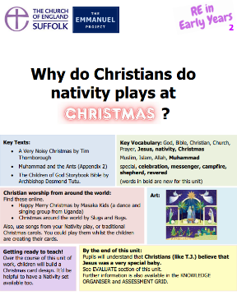
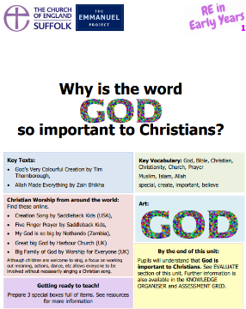
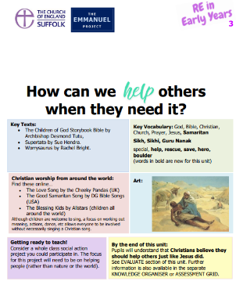
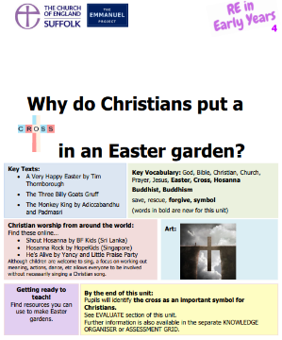
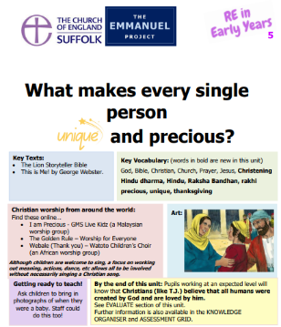
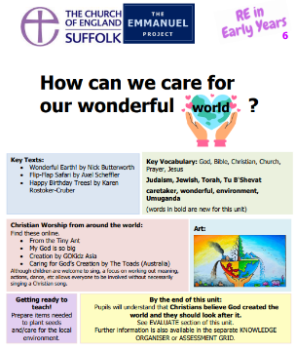
Autumn 1 | Autumn 2 | Spring 1 | Spring 2 |  | Summer 1 | Summer 2
Big Question 1 – What does the word ‘God’ mean? | Big Question 2 – Why are some people revered? | Big Question 3 – Is it always easy to help someone? | Big Question 4 -Does everyone need some help? | Big Question 5 –Is every one of us special? |  | Big Question 6 – What is really important to do?
Christian  Creation  Why is the word ‘God’ so important to Christians? | Christian  Incarnation  Why do Christians perform nativity plays at Christmas? | Christian  Salvation  How can we help others when they need it? | Christian  Salvation  Why do Christians put a cross in an Easter garden? |  | Christian  Incarnation  What makes every single person unique and precious? | Christian  Creation  How can we care for our wonderful world?
And encounter a… | And encounter a… | And encounter a… | And encounter a… |  | And encounter a… | And encounter a…
Muslim Birth Rite  For example: Why do Muslims want to whisper ‘Allah’ in a baby’s ear? | Muslim Story  For example: Why did Prophet Muhammad rescue some ants? | Sikh Story  For example: Guru Nanak and the Boulder | Buddhist Story  For example: What do Buddhists learn from the Monkey King? |  | Hindu Festival  For example: Raksha Bandhan - How do Hindu brothers and sisters show love? | Jewish Festival  For example: Tu B'Shevat - Why do Jewish children help plant trees?

Suggested RE Long-term plan for Church schools: KS1
Autumn 1 | Autumn 2 | Spring 1 | Spring 2 | Summer 1 | Summer 2 | YEAR  1  OR  A
Big Question 1 - Is it important to belong? |  | Big Question 2 – Why do people celebrate? |  | Big Question 3 – Should everyone learn to pray? |  | YEAR  1  OR  A
Christian  church  Why is belonging to God and the church family important to Christians? | Jewish  mitzvot  Why is learning to do good deeds so important to Jewish people? | Hindu  devotion  How does a Hindu celebrate devotion to God at the festival of Holi? | Christian  , resurrection  What are the best symbols of Jesus’ death & resurrection at Easter? | Jewish  tefillah  Why do Jewish families say so many prayers and blessings? | Christian  worship  Why do Christians pray to God and worship him? | YEAR  1  OR  A
Autumn 1 | Autumn 2 | Spring 1 | Spring 2 | Summer 1 | Summer 2 | YEAR 2 OR  B
Big Question 4: What do people believe is important? |  | Big Question 5: Who is it right to  follow? |  | Big Question 6: Can books and  stories be good teachers? |  | YEAR 2 OR  B
Jewish  teshuvah  Why do Jewish families talk about repentance at New Year? | Christian  Saviour  Why was Jesus given the name ‘Saviour’? | Muslim  compassion  How do some Muslims show Allah is compassionate and merciful? | Christian  trust  Why do Christians trust Jesus and follow him? | Jewish  Torah  Why is the Torah such a joy for the Jewish community? | Christian  parable  What did Jesus teach about God in his parables? | YEAR 2 OR  B

Suggested RE Long-term plan for Church schools: LKS2
Church schools must adopt a scheme of work for RE in line with the requirements of the Church of England’s Statement of Entitlement for RE.
At least 50% of RE time should focus on Christian concepts and beliefs.
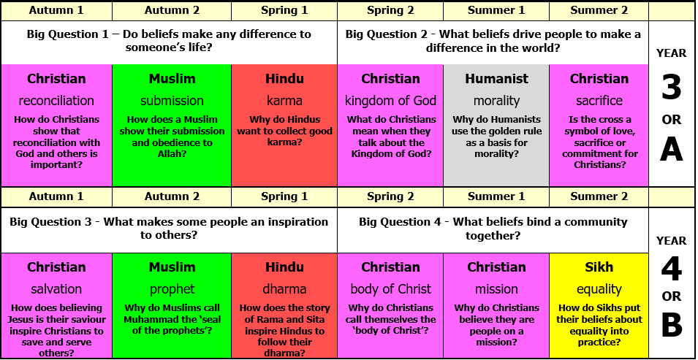

Suggested RE Long-term plan for Church schools: UKS2
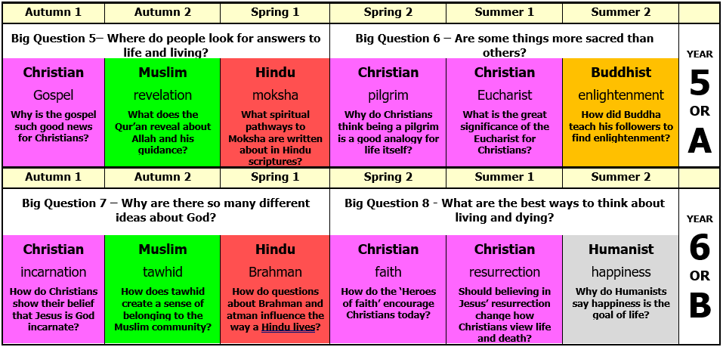
Church schools must adopt a scheme of work for RE in line with the requirements of the Church of England’s Statement of Entitlement for RE.
At least 50% of RE time should focus on Christian concepts and beliefs.

